Database ER Diagram (Ecommerce System)
- Database ER Diagram
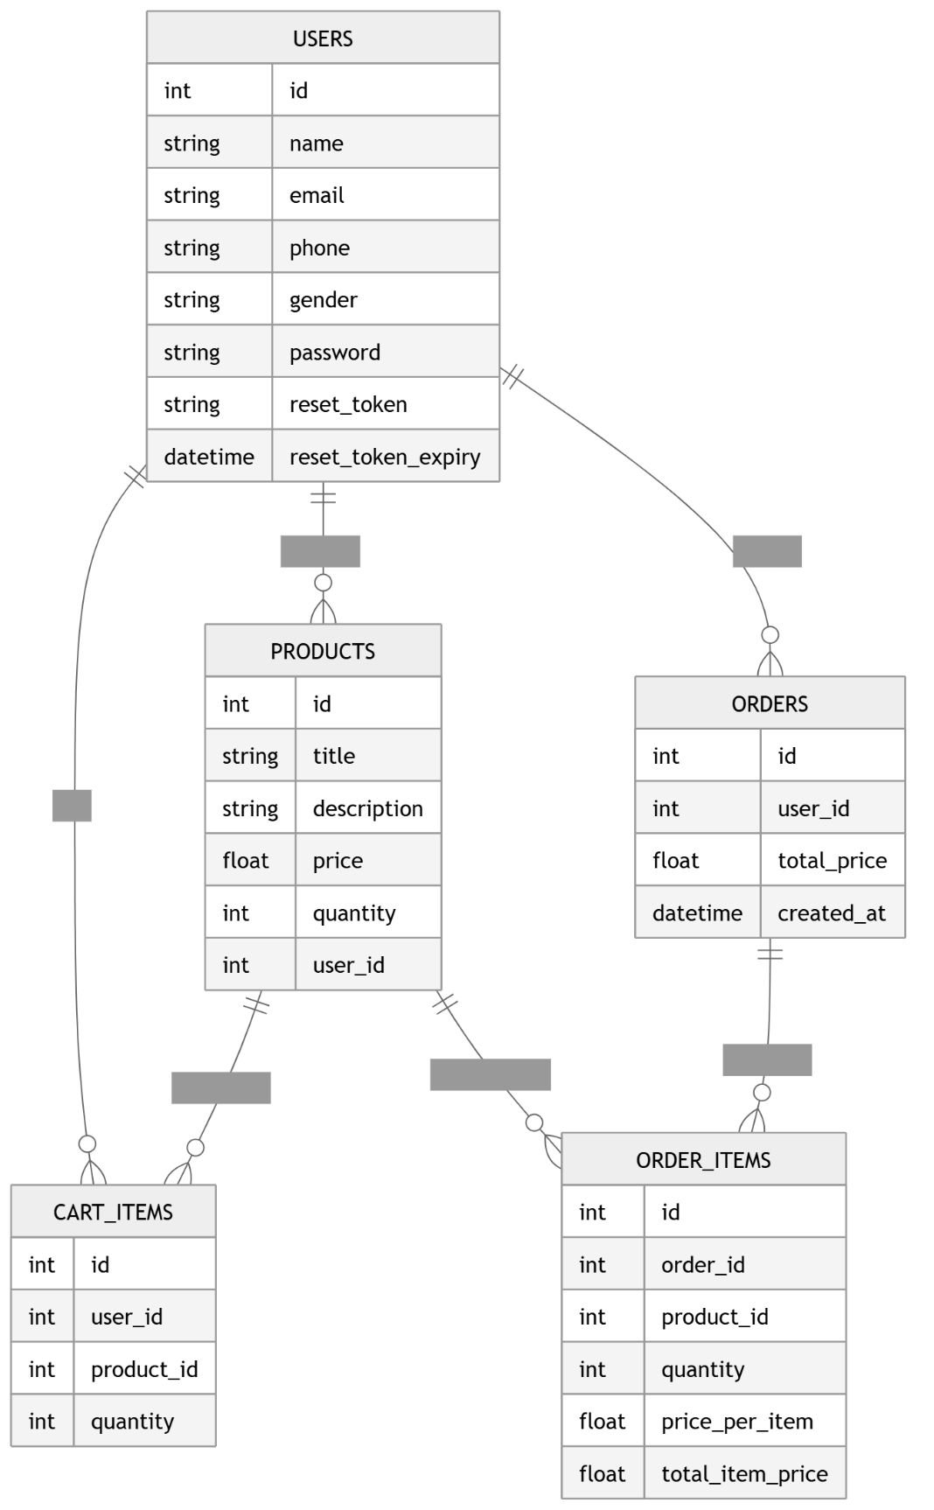

- Explanation
- Users
Stores user information:
- Login credentials
- Profile data
- Reset password tokens

- Products
Each product:
- Belongs to a user (seller/admin)
- Can be added to cart or orders

- Cart Items
Represents:
- Products added by a user
- Temporary storage before ordering

- Orders
Represents:
- Final purchase made by user
- Contains multiple order items

- Order Items
Represents:
- Individual products inside an order
- Stores quantity and price at purchase time

- Why This ER Diagram is Professional
- Normalized structure
- Many-to-Many relationships handled properly
- Real-world ecommerce design
- Industry-level schema (used in Shopify/Amazon-like systems)

